NALAIYA THIRAN PROJECT BASED LEARNING ON

PROFESSIONAL READLINESS FOR INNOVATION,

EMPLOYNMENT AND ENTERPRENEURSHIP

Personal Expense Tracker Application

A PROJECT REPORT

AKASH PETER P (714019205005)

KARPAGAMAINTHAN M (714019205023)

NAVEEN E (714019205031)

NITHISH KUMAR T (714019205034)

B.TECH INFORMATION TECHNOLOGY

SRI SHAKTHI INSTITUTE OF ENGINEERING AND

TECHNOLOGY, COIMBATORE -62

**1.INTRODUCTION**

1.1 Project Overview

In simple words, personal finance entails all the financial decisions and activities that a Finance app makes your life easier by helping you to manage your finances efficiently. A personal finance app will not only help you with budgeting and accounting but also give you helpful insights about money management.

Personal finance applications will ask users to add their expenses and based on their expenses wallet balance will be updated which will be visible to the user. Also, users can get an analysis of their expenditure in graphical forms. They have an option to set a limit for the amount to be used for that particular month if the limit is exceeded the user will be notified with an email alert.

1.2 Purpose

Tracking your spending can also help you identify [serious problems](https://www.thebalancemoney.com/signs-you-have-spending-issues-2385517) in how you manage your money. For example, as you gauge your expenses over a period of months or even years, you might observe that your annually increasing monthly rent now makes up an outsized percentage of your monthly income or that you aren't earning enough to lead the lifestyle you imagined. To correct problems like these, you might have to make more drastic life changes such as moving to a more affordable residence or getting a second job to earn more money. It won't be easy, but it will be worthwhile if it puts you on track financially.

**2. LITERATURE SURVEY**

2.1 Existing Problem

Earlier, our parents use to track all their expenses by writing down in a small notebook and calculating it on their own Even still many of them follow the same to maintain their financial expenses even some of them don’t care of their expenses and spendings.

Not only in our homes, Expenses are need to be tracked in many large scale and small scale sectors such as in many schools, colleges, marketing companies , departmental stores , etc

In short, tracking our financial expenses is a great deal especially in this scenario so making those tracking easier is the job of this application.

2.2 Problem Statement Defintion

A well-articulated customer problem statement allows us to find the ideal solution for the challenges our customers face. Throughout the process, you’ll also be able to empathize with your customers, which helps you better understand how they perceive your product or service.

|  |  |  |  |  |  |
| --- | --- | --- | --- | --- | --- |
| **Problem Statement (PS)** | **I am (Customer)** | **I’m trying to** | **But** | **Because** | **Which makes me feel** |
| PS-1 | an employee. | Make a monthly budget. | There are no facilities to set a  budget. | I need to save money for my future plans. | Frustrated. |
| PS-2 | A manager. | Keep track of my expenses. | Can’t categorize the various types of  expenses. | There is no option to organize the various expenses. | Uncomfortable. |

**3.IDEATION & PROPOSED SOLUTION**

3.1 Empathy Map Canvas

3.2 Ideation & Brainstorming

**Brainstorm & Idea Prioritization Template:**

Brainstorming provides a free and open environment that encourages everyone within a team to participate in the creative thinking process that leads to problem solving. Prioritizing volume over value, out-of-the-box ideas are welcome and built upon, and all participants are encouraged to collaborate, helping each other develop a rich amount of creative solutions.

Use this template in your own brainstorming sessions so your team can unleash their imagination and start shaping concepts even if you're not sitting in the same room.

Reference: <https://www.mural.co/templates/empathy-map-canvas>

**Step-1: Team Gathering, Collaboration and Select the Problem Statement**

**Step-2: Brainstorm, Idea Listing and Grouping**

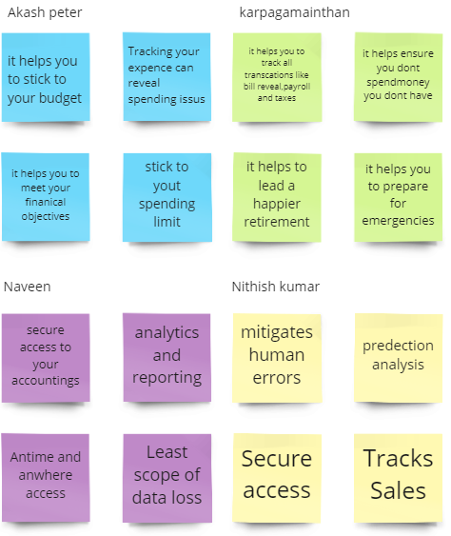

**Step-3: Idea Prioritization**

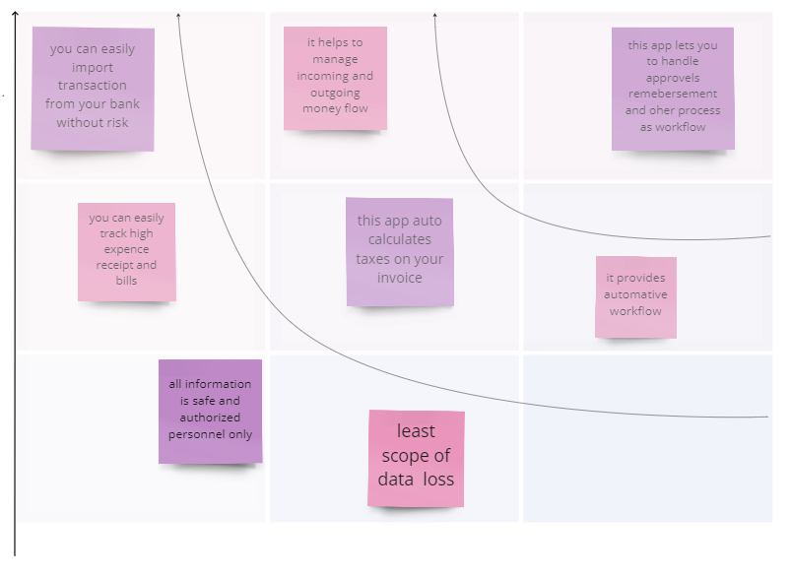

3.3 Proposed Solution

|  |  |  |
| --- | --- | --- |
| 1. | Idea / Solution description | Due to the busy and hectic lifestyle people tend to overlook their budget and end up spending an excessive amount of money since they  usually didn’t plan their budget wisely. user cannot predict future expenses. While they can write down their expenses in a excel spreadsheet, their lack of knowledge in  managing finances will be a problem |
| 2. | Novelty / Uniqueness | This application tracks your every expenses anywhere and anytime without using the paper work. Just click and enter your expenditure. to avoid data loss, quick settlements and reduce human error. To provide the pie chart or graph lines in this application. |
| 3. | Social Impact / Customer Satisfaction | Using this application one can track their personal expenses and frame a monthly/annual budget. If your expense exceeded than specified limit, the application will show you an  alert message in form of a pie chart. |
| 4. | Business Model (Revenue Model) | Business people can use subscription/premium feature of this application to gain revenue. |
| 5. | Scalability of the Solution | IBM cloud will automatically allocate the storage for the users. |

3.4 Problem Solution Fit

**4.REQUIREMENT ANALYSIS**

4.1 Functional Requirements

|  |  |  |
| --- | --- | --- |
| **FR No.** | **Functional Requirement (Epic)** | **Sub Requirement (Story / Sub-Task)** |
| FR-1 | User Registration | User should Register using their Email. |
| FR-2 | Login | Enter username (Email) and password |
| FR-3 | Select Method | Two methods are provided  1-Manual (Manually Enter the expenses) 2-Bank (Link Bank Account) |
| FR-4 | Manual Method | Manually user can enter the expenses by using voice recognition by simply saying category and amount spent on that also can use Barcode Scanner by using Bill provided while purchasing. |
| FR-5 | Bank Method | In Bank method user have to Enter their Bank details in prior and all the Bank using transactions are detected and tracker accordingly. |
| FR-6 | Expense Tracker | This application should graphically represent the expense in the form of report. |
| FR-7 | Report generation | Graphical representation of report must be generated. |
| FR-8 | Category | This application shall allow users to add categories of their expenses. |

4.2 Non Functional Requirements

|  |  |  |
| --- | --- | --- |
| **FR No.** | **Non-Functional Requirement** | **Description** |
| NFR-1 | **Usability** | Helps to keep an accurate record of your income and expenses. |
| NFR-2 | **Security** | Budget tracking apps are considered very safe from those who commit cyber crimes. |
| NFR-3 | **Reliability** | Each data record is stored on a well built efficient database schema. There is no risk of data loss. |
| NFR-4 | **Performance** | The types of expense are categories along with an option. Throughput of the system is increased due to light weight database support. |
| NFR-5 | **Availability** | The application must have a 100% up-time. |
| NFR-6 | **Scalability** | The ability to appropriately handle increasing demands. |

**5.PROJECT DESIGN**

5.1 Data Flow Diagram

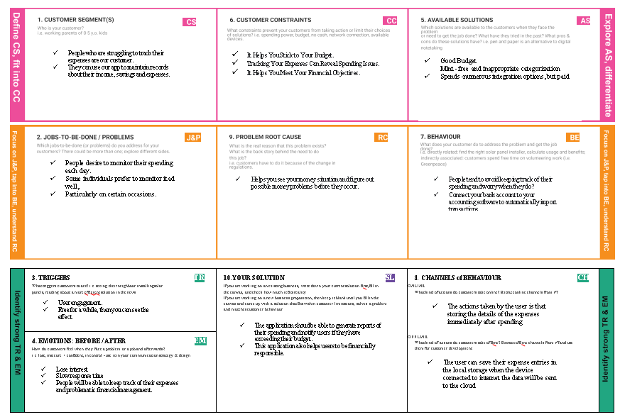

5.2 Solution & Technical Architecture

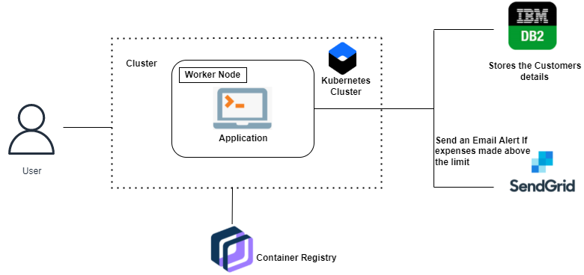

5.3 User Stories

|  |  |  |  |  |  |  |
| --- | --- | --- | --- | --- | --- | --- |
| **User Type** | **Functional Requirement**  **(Epic)** | **User Story Number** | **User Story / Task** | **Acceptance criteria** | **Priority** | **Release** |
| Customer (Mobile user) | Registration | USN-1 | As a user, I can register for the application by entering my email, and password, and confirming my password. | I can access my account / dashboard | High | Sprint-1 |
|  |  | USN-2 | As a user, I will receive a confirmation email  once I have registered for the application | I can receive a  confirmation email & click confirm | High | Sprint-1 |
|  |  | USN-3 | As a user, I can register for the application  through Facebook | I can register & access the  dashboard with Facebook Login | Low | Sprint-2 |
|  |  | USN-4 | As a user, I can register for the application  through Gmail |  | Medium | Sprint-1 |
|  | Login | USN-5 | As a user, I can log into the application by  entering email & password |  | High | Sprint-1 |
|  | Dashboard | USN-8 | As a user, I need to enter my income and expenses | I can view my insights about spending | High | Sprint-2 |
|  |  | USN-9 | As a user, I need to set a budget alert for a month or a week | I can set spending alerts for a month or a week | Medium | Sprint-2 |
|  |  | USN-10 | As a user, I need to get email notifications about my weekly and monthly spendings and earning | I can see my insights through mail about weekly and monthly insights | Medium | Sprint-2 |
| Customer Care Executive |  | USN-11 | As a customer care executive, I can solve login issues and other issues of the application | I can provide customer support 24/7 | Medium | Sprint-3 |
| Administrator |  | USN-12 | As an administrator, I can update the features  and roll out a new version of application | I can fix the bugs and add  features as per the request of the user | Low | Sprint-4 |

**6.PROJECT PLANNING & SCHEDULING**

6.1 Sprint Planning & Estimation

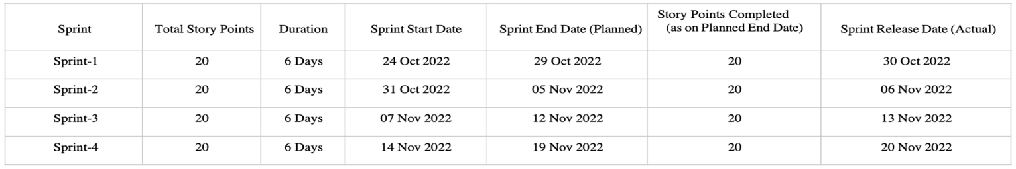

6.2 Sprint Delivery Schedule

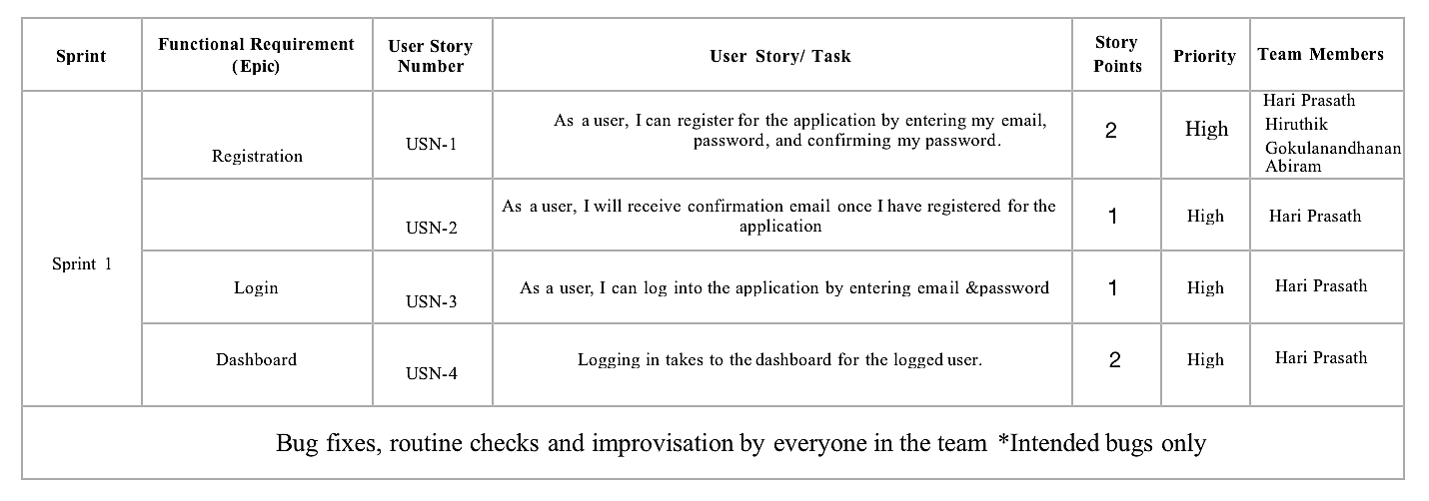

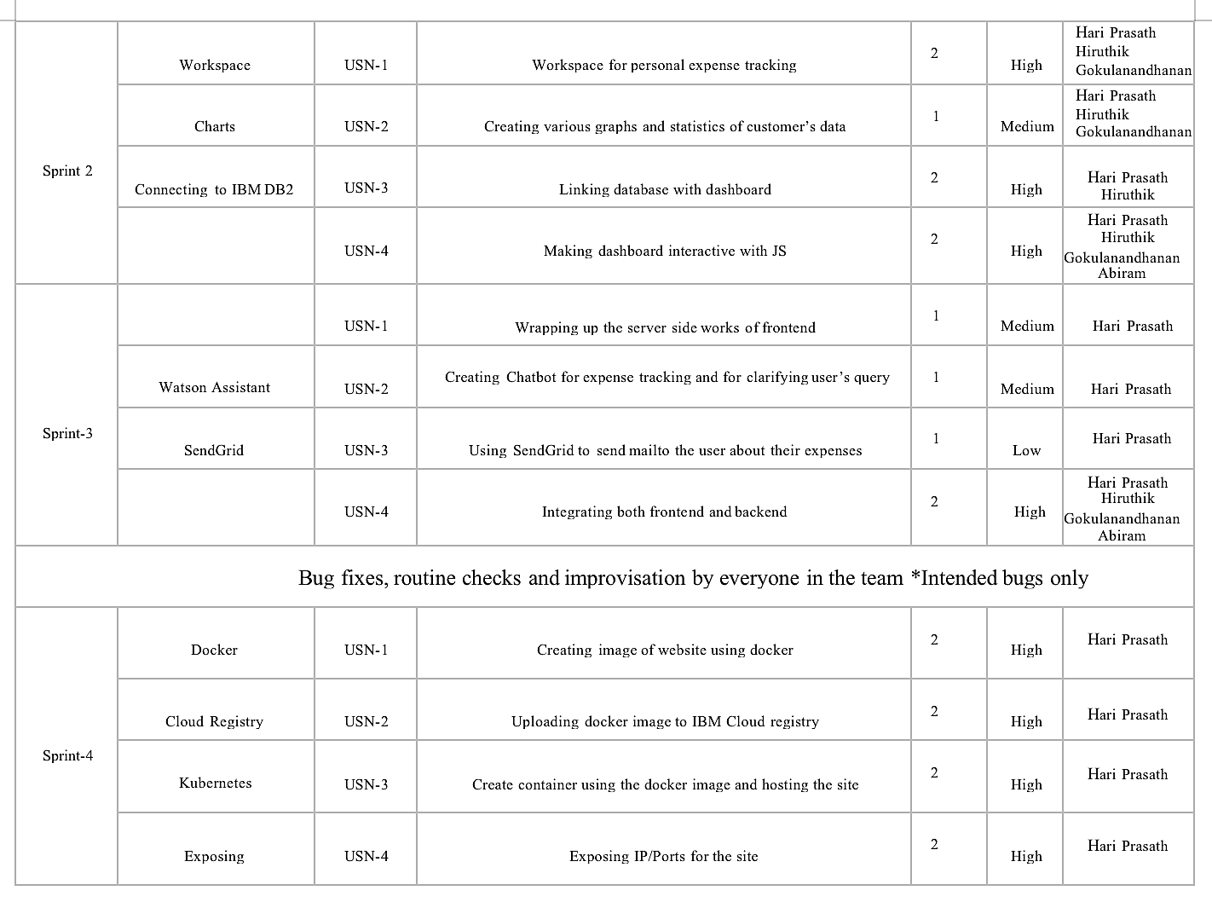

6.3 Reports from Jira

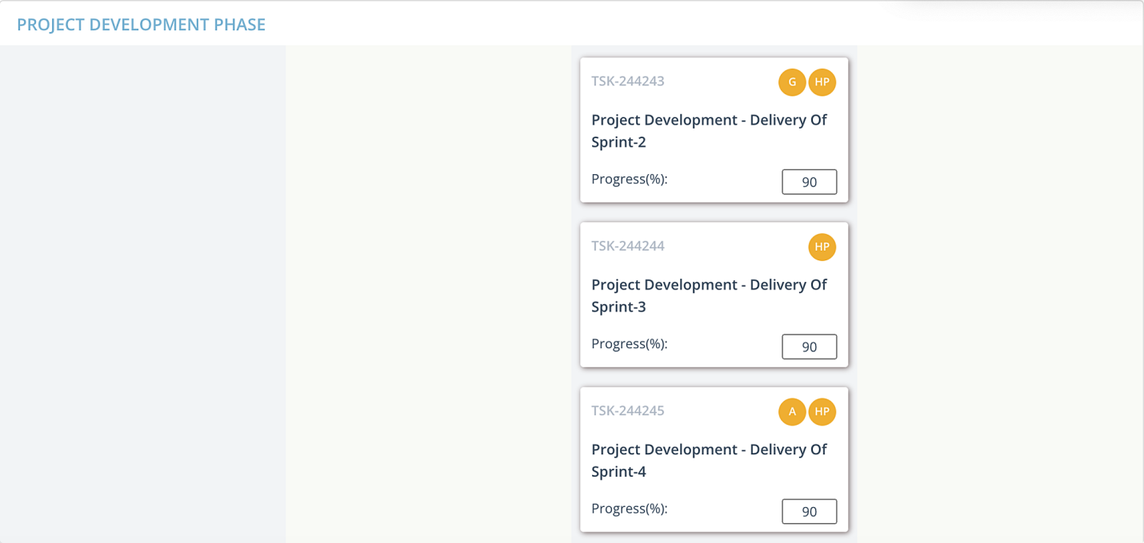

**7.CODING AND SOLUTIONING**

**7.1 LOGIN PAGE**

**CODE:**

<!DOCTYPE html>

<html>

<head>

<title>Animated Login Form</title>

<link rel="stylesheet" type="text/css" href="..\static\css\login.css">

<link href="https://fonts.googleapis.com/css?family=Poppins:600&display=swap" rel="stylesheet">

<script src="https://kit.fontawesome.com/a81368914c.js"></script>

<meta name="viewport" content="width=device-width, initial-scale=1">

</head>

<body >

<img class="wave" src="..\static\images\wave.png">

<div class="container">

<div class="img">

<div id="png"><a href="/" title="HOME"><img style="width:75px; height:75px ; " src="..\static\images\home-page.png"></a></div>

<img src="..\static\images\bg.svg">

</div>

<div class="login-content">

<form action='/login' method="POST">

<div class="msg">{{ msg }}</div>

<img src="..\static\images\avatar.svg">

<h2 class="title">Welcome</h2>

<div class="input-div one">

<div class="i">

<i class="fas fa-user"></i>

</div>

<div class="div">

<h5>Username</h5>

<input type="text" name="username" class="input" required>

</div>

</div>

<div class="input-div pass">

<div class="i">

<i class="fas fa-lock"></i>

</div>

<div class="div">

<h5>Password</h5>

<input type="password" name="password" class="input" required>

</div>

</div>

<a href="#">Forgot Password?</a>

<input type="submit" class="btn" value="Login">

<span>OR</span>

<div><b>Login with</b></div>

<div>

<ul>

<li><a href="#"><i class="fab fa-facebook" aria-hidden="true"></i></a></li>

<li><a href="#"><i class="fab fa-twitter" aria-hidden="true"></i></a></li>

<li><a href="#"><i <i class="fab fa-google" aria-hidden="true"></i></a></li>

<li><a href="#"><i class="fab fa-linkedin" aria-hidden="true"></i></a></li>

<li><a href="#"><i class="fab fa-instagram" aria-hidden="true"></i></a></li>

</ul>

</div>

<div class="app" ><b>Don't have an account?</b><a id="app1" href="\signup">REGISTER.here</a></div>

</form>

</div>

</div>

<script type="text/javascript" src="..\static\js\login.js"></script>

</body>

</html>

**7.2 REGISTER PAGE**

**CODE :**

<html>

<head>

<meta charset="utf-8">

<title>Sign-up</title>

<link href="..\static\css\signup.css" rel="stylesheet">

<script src="https://kit.fontawesome.com/a81368914c.js"></script>

<link rel="stylesheet" href="https://maxcdn.bootstrapcdn.com/bootstrap/4.0.0/css/bootstrap.min.css" integrity="sha384-Gn5384xqQ1aoWXA+058RXPxPg6fy4IWvTNh0E263XmFcJlSAwiGgFAW/dAiS6JXm" crossorigin="anonymous">

</head>

<body>

<!--container---------------------->

<div class="container" >

<!--sign-up-box-container--->

<div class="sign-up">

<div id="png"><a href="/" title="HOME"><img style="width:55px; height:55px ; " src="..\static\images\home-page.png"></a></div>

<!--heading-->

<form action="/register" method="post">

<div class="msg">{{ msg }}</div>

<h1 class="heading">Hello,Friend</h1>

<!--name-box-->

<div class="text">

<img height="20px" src="..\static\images\user.png" />

<input placeholder="Name" type="text" name="username"/>

</div>

<!--Email-box-->

<div class="text">

<img height="12px" src="..\static\images/email.png" />

<input placeholder=" Example@gmail.com" type="email" name="email"" />

</div>

<!--Password-box-->

<div class="text">

<img height="20px" src="..\static\images\password.png" />

<input placeholder=" Password" type="password" name="password"/>

</div>

<div class="or"><b>OR</b></div>

<div class="s1"><p><b>Sign-up with</b></p></div>

<div>

<ul>

<li><a href="#"><i class="fab fa-facebook" aria-hidden="true"></i></a></li>

<li><a href="#"><i class="fab fa-twitter" aria-hidden="true"></i></a></li>

<li><a href="#"><i class="fab fa-google" aria-hidden="true"></i></a></li>

<li><a href="#"><i class="fab fa-linkedin" aria-hidden="true"></i></a></li>

<li><a href="#"><i class="fab fa-instagram" aria-hidden="true"></i></a></li>

</ul>

</div>

<!--trems-->

<div class="trems">

<input class="check" type="checkbox" required/>

<p class="conditions">I read and agree to <a href="#">Trems &amp; Conditions</a></p>

</div>

<!--button-->

<div class="toop">

<button type="submit" class="btn btn-primary" >CREATE ACCOUNT</button> </div>

</form>

<!--sign-in-->

<div class="t"><p class="conditions" id="p3">Already have an account <a href="/signin">Sign in</a></p> </div></div>

</div>

<!--text-container-->

<div class="text-container">

<h1 style="color: #2d2c2c;font-family:cursive;">Glad to see you</h1>

<div class="diag"><img class="fig1" width="100%" height="105%" src="..\static\images\Inkeddia_LI.jpg"</div>

<div class="para"> <b>Welcome</b>,Please Fill in the blanks for sign up</div>

</div>

</div>

</body>

</html>

**7.3 DASHBOARD PAGE**

**CODE :**

{% extends 'base.html' %}

{% block body %}

<div class="container ">

<h3 class="mt-3">EXPENSES</h3>

{% if expense is defined %}

{% for row in expense %}

<div class="row">

<div class="col-md-12">

<div class="card shadow-sm mb-2 bg-white rounded"></div>

<div class="card-body">

<div class="row">

<div class="col-md-2">

<span class="btn btn-outline-dark">{{row[2]}}</span> </div>

<div class="col-md-2 mt-3"><H6>{{row[3]}}</H6></div>

<div class="col-md-2 mt-3" > ₹<span style=" color: rgb(255, 0, 0) "> {{row[4]}} </div>

<div class="col-md-2 mt-3">

<span class="badge badge-pill badge-info">{{row[5]}}</span>

</div>

<div class="col-md-2 mt-3">

<span class="badge badge-primary">{{row[6]}}</span>

</div>

<div class="col-md-1 mt-3">

<a href="/edit/{{row[0]}} " class="btn btn-sm btn-success">Edit</a>

</div>

<div class="col-md-1 mt-3">

<a href="/delete/{{row[0]}}" class="btn btn-sm btnDelete btn-success">Delete</a>

</div>

</div>

</div>

</div>

</div>

<!--when no DATA-Found-->

{% else %}

<div class="card shadow-sm mb-2 bg-white rounded"></div>

<div class="card-body">

<div style="text-align: center ; font-family: monospace; color:red ; "><h5><a href="/add"> ADD-DATA </a> to Display</h3></div>

<img width=60% src="../static/images/not-found.png">

</div>

{% endfor %}

{% endif %}

<div class="row">

<div class="col-md-6">

<h3 class="mt-5">Expense Breakdown</h3>

<div class="card shadow mb-2 bg-white rounded-bottom">

<div class="card-body ">

<div class="row">

<div class="col-md-6">Food</div>

<div id="tfood" class="col-md-6"> {{ t_food}} </div>

</div>

</div>

</div>

<div class="card shadow mb-2 bg-white rounded">

<div class="card-body">

<div class="row">

<div class="col-md-6">Entertainment</div>

<div id="tentertainment" class="col-md-6"> {{ t_entertainment}} </div>

</div>

</div>

</div>

<div class="card shadow mb-2 bg-white rounded">

<div class="card-body">

<div class="row">

<div class="col-md-6">Business</div>

<div id="tbusiness" class="col-md-6"> {{t_business}} </div>

</div>

</div>

</div>

<div class="card shadow mb-2 bg-white rounded">

<div class="card-body">

<div class="row">

<div class="col-md-6">Rent</div>

<div id="trent" class="col-md-6"> {{ t_rent }} </div>

</div>

</div>

</div>

<div class="card shadow mb-2 bg-white rounded">

<div class="card-body">

<div class="row">

<div class="col-md-6">EMI</div>

<div id="temi" class="col-md-6">{{ t_EMI }} </div>

</div>

</div>

</div>

<div class="card shadow mb-2 bg-white rounded">

<div class="card-body">

<div class="row">

<div class="col-md-6">Other</div>

<div id="tother" class="col-md-6"> {{ t_other}}</div>

</div>

</div>

</div>

<div class="card shadow mb-2 btn-outline-danger rounded-pill">

<div class="card-body">

<div class="row">

<div class="col-md-6">Total</div>

<div class="col-md-6">₹ {{total}} </div>

</div>

</div>

</div>

</div>

<div class="col-md-6">

<canvas id="myChart" width="400" height="400"></canvas>

<script>

let food = document.getElementById('tfood').innerHTML

let entertainment = document.getElementById('tentertainment').innerHTML

let business = document.getElementById('tbusiness').innerHTML

let rent = document.getElementById('trent').innerHTML

let emi = document.getElementById('temi').innerHTML

let other = document.getElementById('tother').innerHTML

var ctx = document.getElementById('myChart').getContext('2d');

var myChart = new Chart(ctx, {

type: 'doughnut',

data: {

labels: ['Food', 'Entertainment', 'Business', 'Rent', 'EMI', 'Other'],

datasets: [{

label: 'Expenses Chart',

data: [food, entertainment, business, rent, emi, other],

backgroundColor: [

'rgb(255, 99, 132)',

'rgb(0, 0, 0)',

'rgb(255, 205, 86)',

'rgb(201, 203, 207)',

'rgb(54, 162, 235)',

'rgb(215, 159, 64)'

],

}]

},

options: {

responsive: true,

plugins: {

legend: {

position: 'bottom',

},

title: {

display: true,

text: 'EXPENSE BREAKDOWN'

}

}

}

});

</script>

</div>

</div>

</div>

{% endblock %}

**7.4 ADDEXPENSES PAGE**

**CODE:**

{% extends 'base.html' %}

{% block body %}

<div class="container">

<div class="row">

<div class="col-md-6">

<h3>Add Expense</h3>

<form action="/addexpense" method="POST">

<div class="form-group">

<label for="">Date</label>

<input class="form-control" type="datetime-local" name="date" id="date"></div>

<div class="form-group"> <label for="">Expense name</label>

<input class="form-control" type="text" name="expensename" id="expensename">

</div>

<div class="form-group">

<label for="">Expense Amount</label>

<input class="form-control" type="number" min="0" name="amount" id="amount">

</div>

<div class="form-group">

<label for=""></label>

<select class="form-control" name="paymode" id="paymode">

<option selected hidden>Pay-Mode</option>

<option name="cash" value="cash">cash</option>

<option name="debitcard" value="debitcard">debitcard</option>

<option name="creditcard" value="creditcard">creditcard</option>

<option name="epayment" value="epayment">epayment</option>

<option name="onlinebanking" value="onlinebanking">onlinebanking</option>

</select>

<div class="form-group">

<label for=""></label>

<select class="form-control" name="category" id="category">

<option selected hidden>Category</option>

<option name = "food" value="food">food</option>

<option name = "entertainment" value="entertainment">Entertainment</option>

<option name = "business" value="business">Business</option>

<option name ="rent" value="rent">Rent</option>

<option name = "EMI" value="EMI">EMI</option>

<option name = "other" value="other">other</option>

</select>

</div>

<input class="btn btn-danger" type="submit" value="Add" id="">

</form>

<div style="position: relative; left: 590px; top: -460px;" class="imagge">

<img width="90%" height="90%" src="../static/images/addd.jpg" class="rounded float-left" alt="...">

</div>

</div>

</div>

</div>

{% endblock %}

**8. ADVANTAGES AND DISADVANTAGES**

8.1 Advantages

It’s simple to set up and use. When you’re creating your own method of tracking your finances, you first have to figure out how you’re going to do that. Are you going to use pen and paper, or software, or an excel spreadsheet? What are you going to track? How are you going to input that data, and how often are you going to do it? With an automated app, it tracks everything for you in real time. It has a wealth of information, so no matter what data you feel is important to track, it is all there and available for you – you just need to take a look to see it. There’s an easy user interface for everything as well. Whether you want to [set up a budget](https://maplemoney.com/control-your-spending-with-a-budget/), track a type of expense, or look over your financial history, there’s a tab or an option ready and waiting for you.

8.2 Disadvantages

Even with constant tracking of one's spending habits, there is no guarantee that financial goals will be met. Although this can be considered to be a con of tracking spending, it could be changed into a pro if one makes up his or her mind to keep trying to properly manage all finances. Another con that may occur when spending is being tracked is an error, but this may also be able to be changed into a pro if the person does regular tracking. Frequent tracking of cash spending can allow one to catch and correct errors so that the budget plan is still able to be adhered to despite the mistake.

**9. CONCLUSION**

In conclusion, developing a personal budget and tracking all expenses and spending is acrucial aspect of personal finances. Set aside a fixed amount in a savings account, they say youshould always have three months work of your living expenses in a savings account in case ofemergencies. Lastly, educating the children early in life about personal finances should be amandatory class in every school. Parents need to proactive in teaching their children aboutbanking, credit card, interest rates, and credit. The importance of actually seeing my spending onmy budget sheet was enlightening. However, I know now where I can trim the fat, and bychanging just a few items and cutting back on others, I will see a substantial increase in moneythat I can put into savings.

**10. FUTURE SCOPE**

Provision to add different currencies will be added so that this application is not just

limited to some region but also can be used worldwide and the currency converters will be designed and added in order to convert the different currency rates.

In order to make it more user friendly and less user intensive, when the user tries to

add the same category or vendor to an expense/income record, a duplicate alert will be

presented showing the same category/vendor which the user entered previously for some

expense/income and then he can tap on it and the entries will be automatically filled for the

current record. For example: the user spends US$ 10 at Starbucks (vendor) on drinks

(category) on a particular date and the next day he spends some money at the same place on

the same category, then when he tries to write that on the expense details view, a duplicate

pop up will be presented showing Starbucks as the vendor and drinks as the category. The

54 user taps it and it automatically fills up the detail view making the application less user

intensive.

**11. APPENDIX**

**SOURCE CODE :**

**FULL CODE:**

**KUBERNETES FILES:**

**DOCKERFILE**

FROM python:3.10.6

WORKDIR /app

COPY requirements.txt ./

RUN pip install -r requirements.txt

COPY . .

EXPOSE 5000

CMD ["python","./app.py"]

**GITHUB AND PROJECT DEMO LINK**

GITHUB : https://github.com/IBM-EPBL/IBM-Project-28682-1660115178

DEMO LINK : https://drive.google.com/file/d/16huPsfit-GPm7PUq4Xv_NI5PcVouNoIT/view?usp=sharing